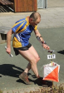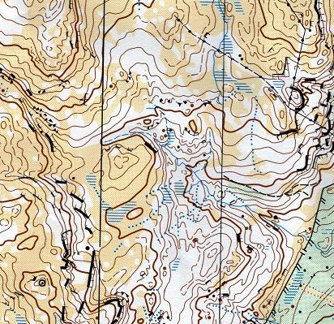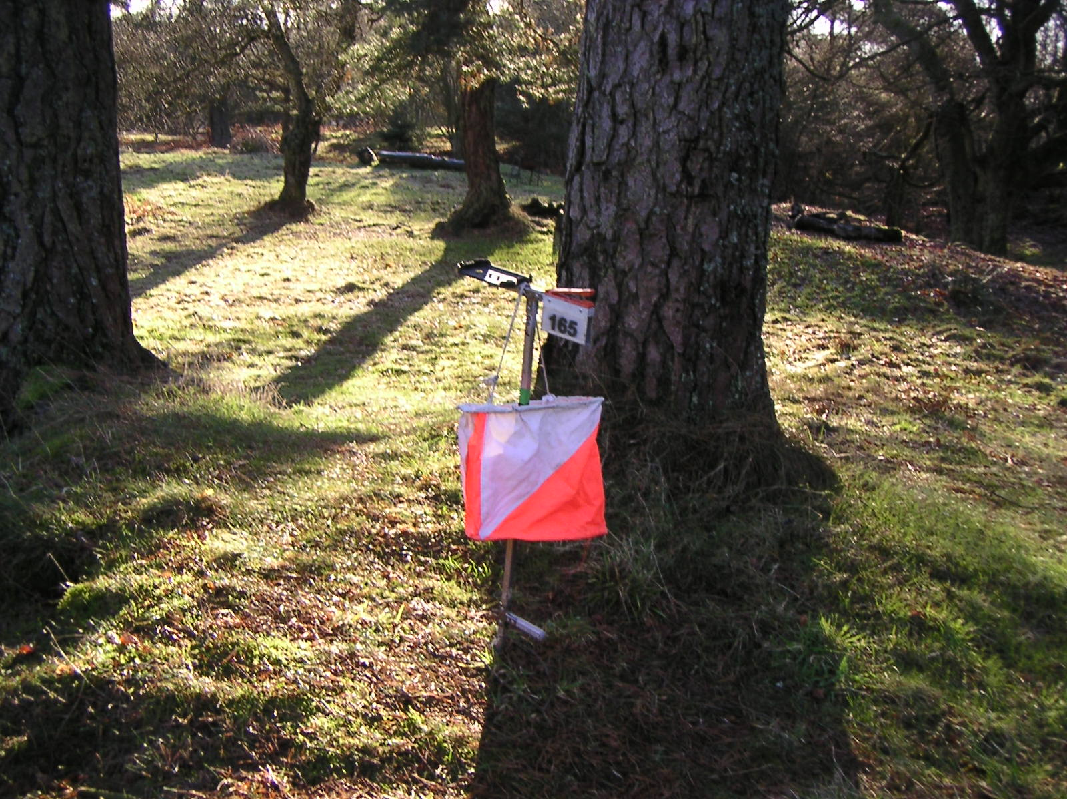
What is Orienteering?
Orienteering is a sport where you use a specially drawn map and a compass to navigate round a route from point to point. Each point is called a control and is located at a particular feature on the map, for instance in a gully or by a boulder (younger orienteers use paths and much simpler features). At each control point there is an orange and white marker – the control flag - as well as a manual or an electronic punch, which records that you have visited the control. The winner is the person who visits the correct controls in the right order and the quickest time.
An event will have courses that are run according to age class and sex, or courses that are classified by length and difficulty – from maybe 1.5 km, mainly on paths for the very young, to 10 km and longer, with lots of hills and few paths, for the more experienced.
Winning requires running speed and stamina, as well as the ability to find the quickest route between controls. At the elite level it is a highly competitive sport involving intense concentration, skill and fitness, running against the best in the world in international competition.
Where can I do it?
Orienteering by its very nature takes place on terrain: forests, moors, fells etc. The most challenging orienteering is usually in the more remote areas where there are fewer paths and the terrain is more demanding. However the challenge of finding the best route in the quickest time can be as difficult in the local park as in the most remote forest!
What do I need?
To get started all you need is a pair of trainers or all-terrain shoes with good grip, and outdoor clothes. A lightweight cagoule may be required if the weather is bad. The other really useful item is, of course, a compass. The map you use will be given to you at the event.

What now?
Orienteering is very much an acquired skill at which practice makes perfect – the more you do, the better you will get. Start at a level which requires less technical skill and move up once you have mastered that level. But beware! It is a sport to which you could become addicted, especially if you love the outdoors or have a competitive streak. Weekends (and holidays) may never be the same again!

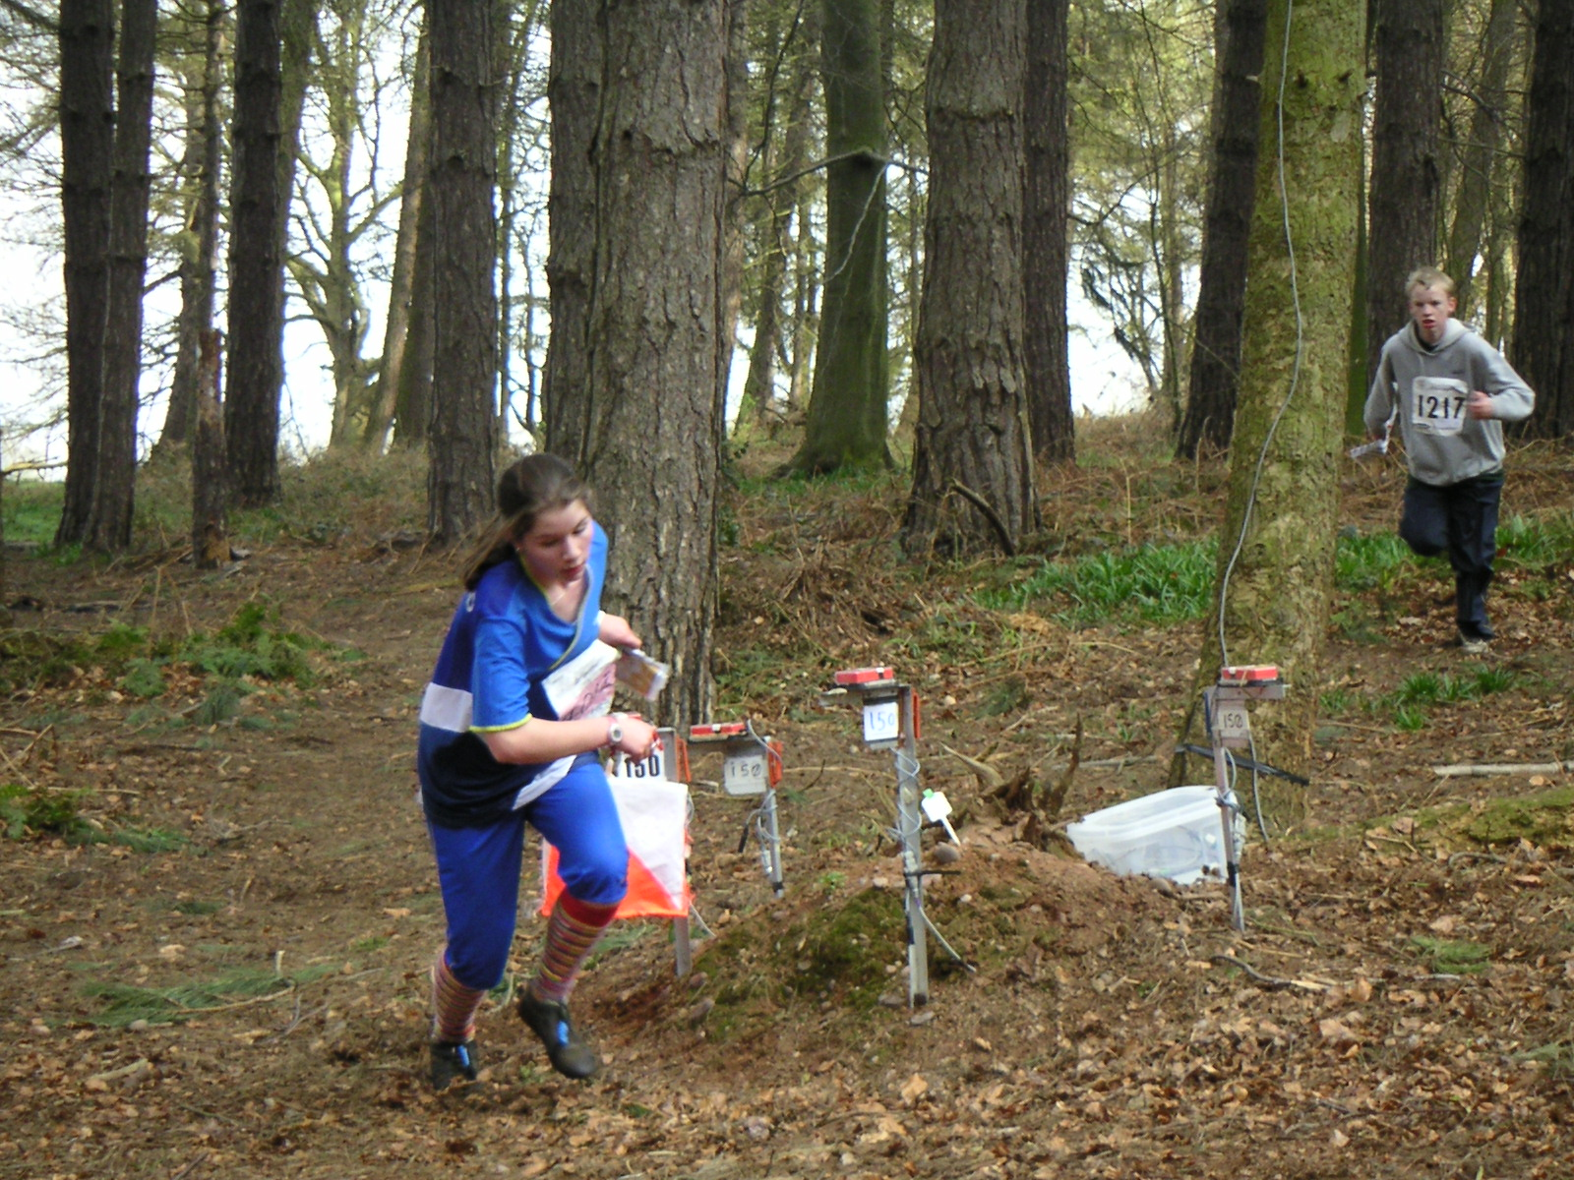
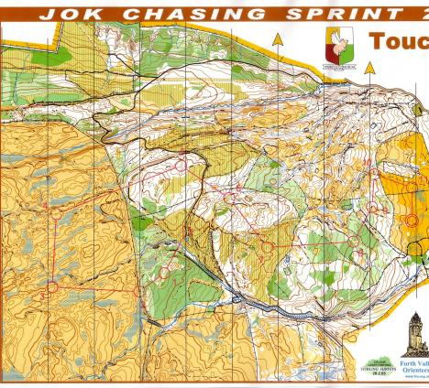


Forth Valley Orienteers

Forth Valley Orienteers (FVO) is one of the leading clubs in Scotland, founded in 1973.
Based around the Forth Valley estuary, our area covers from Linlithgow and Dollar in the East, to Aberfoyle and Callander in the west, including Stirling, Alloa, Dunblane, and Falkirk.
Our logo is the well known Wallace Monument, located in the heart of the club’s area.
During the spring and summer, we organise orienteering events in local areas, and in the winter, training sessions are held in the Stirling University grounds. There is also training available from our coaches for beginners and juniors.
We also organise a number of larger events each year and compete in events organised by other clubs.
As a club we have had great success in relays and inter club competitions – being the winners of UK club competition the Compass Sport Trophy in 2007, 2008, 2009 and 2010.
A number of our members have also been successful at a national level, and represented Scotland and Great Britain
We actively keep in touch with our members via our website and mailing list.

Join us now – junior membership only £2!

Forthcoming Local Events
7 Sep - Callendar Park, Falkirk (5-7pm)
10 Sep - Beecraigs, Linlithgow (2-3pm)
8 Oct - Holyrood Park, Edinburgh (2-3pm)
6 Nov – Dechmont, Livingston (10am-12pm)
27 Nov – Stirling University (10am-12pm)

These events are open to anyone, regardless of age and standard of orienteering. It does not matter how young, old or fit you are, as you can run, walk or jog the course and progress at your own pace. It’s a great sport for runners, joggers and walkers who want to improve their navigation skills or for anyone who loves the outdoors. At the events listed above, there will be short / easy courses suitable for beginners and families, who can always opt to go together as a group. You don’t even need to join the club for your first few sessions - come and try it out for yourself!

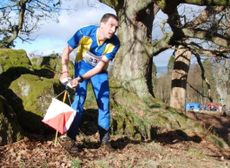
If you would like further information please contact our Secretary, David Nicol, by any of the methods below
Tel: 01786 832123
Email: Secretary@fvo.org.uk
Web: www.fvo.org.uk

with
Forth Valley Orienteers
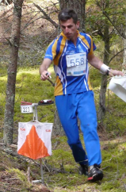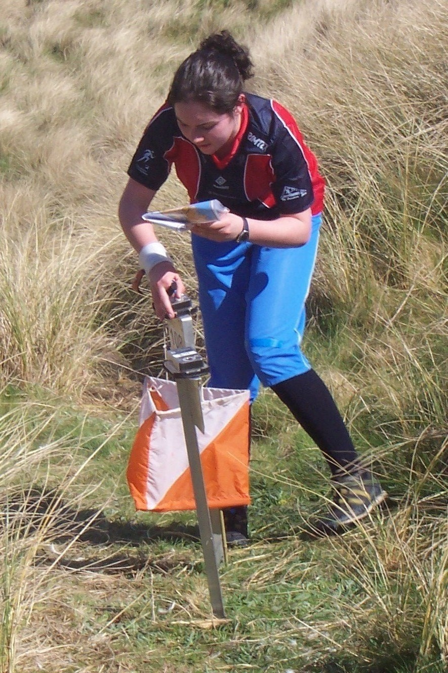
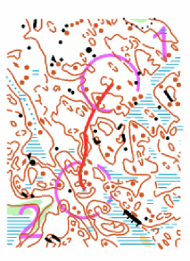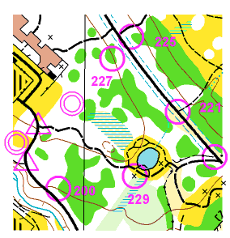
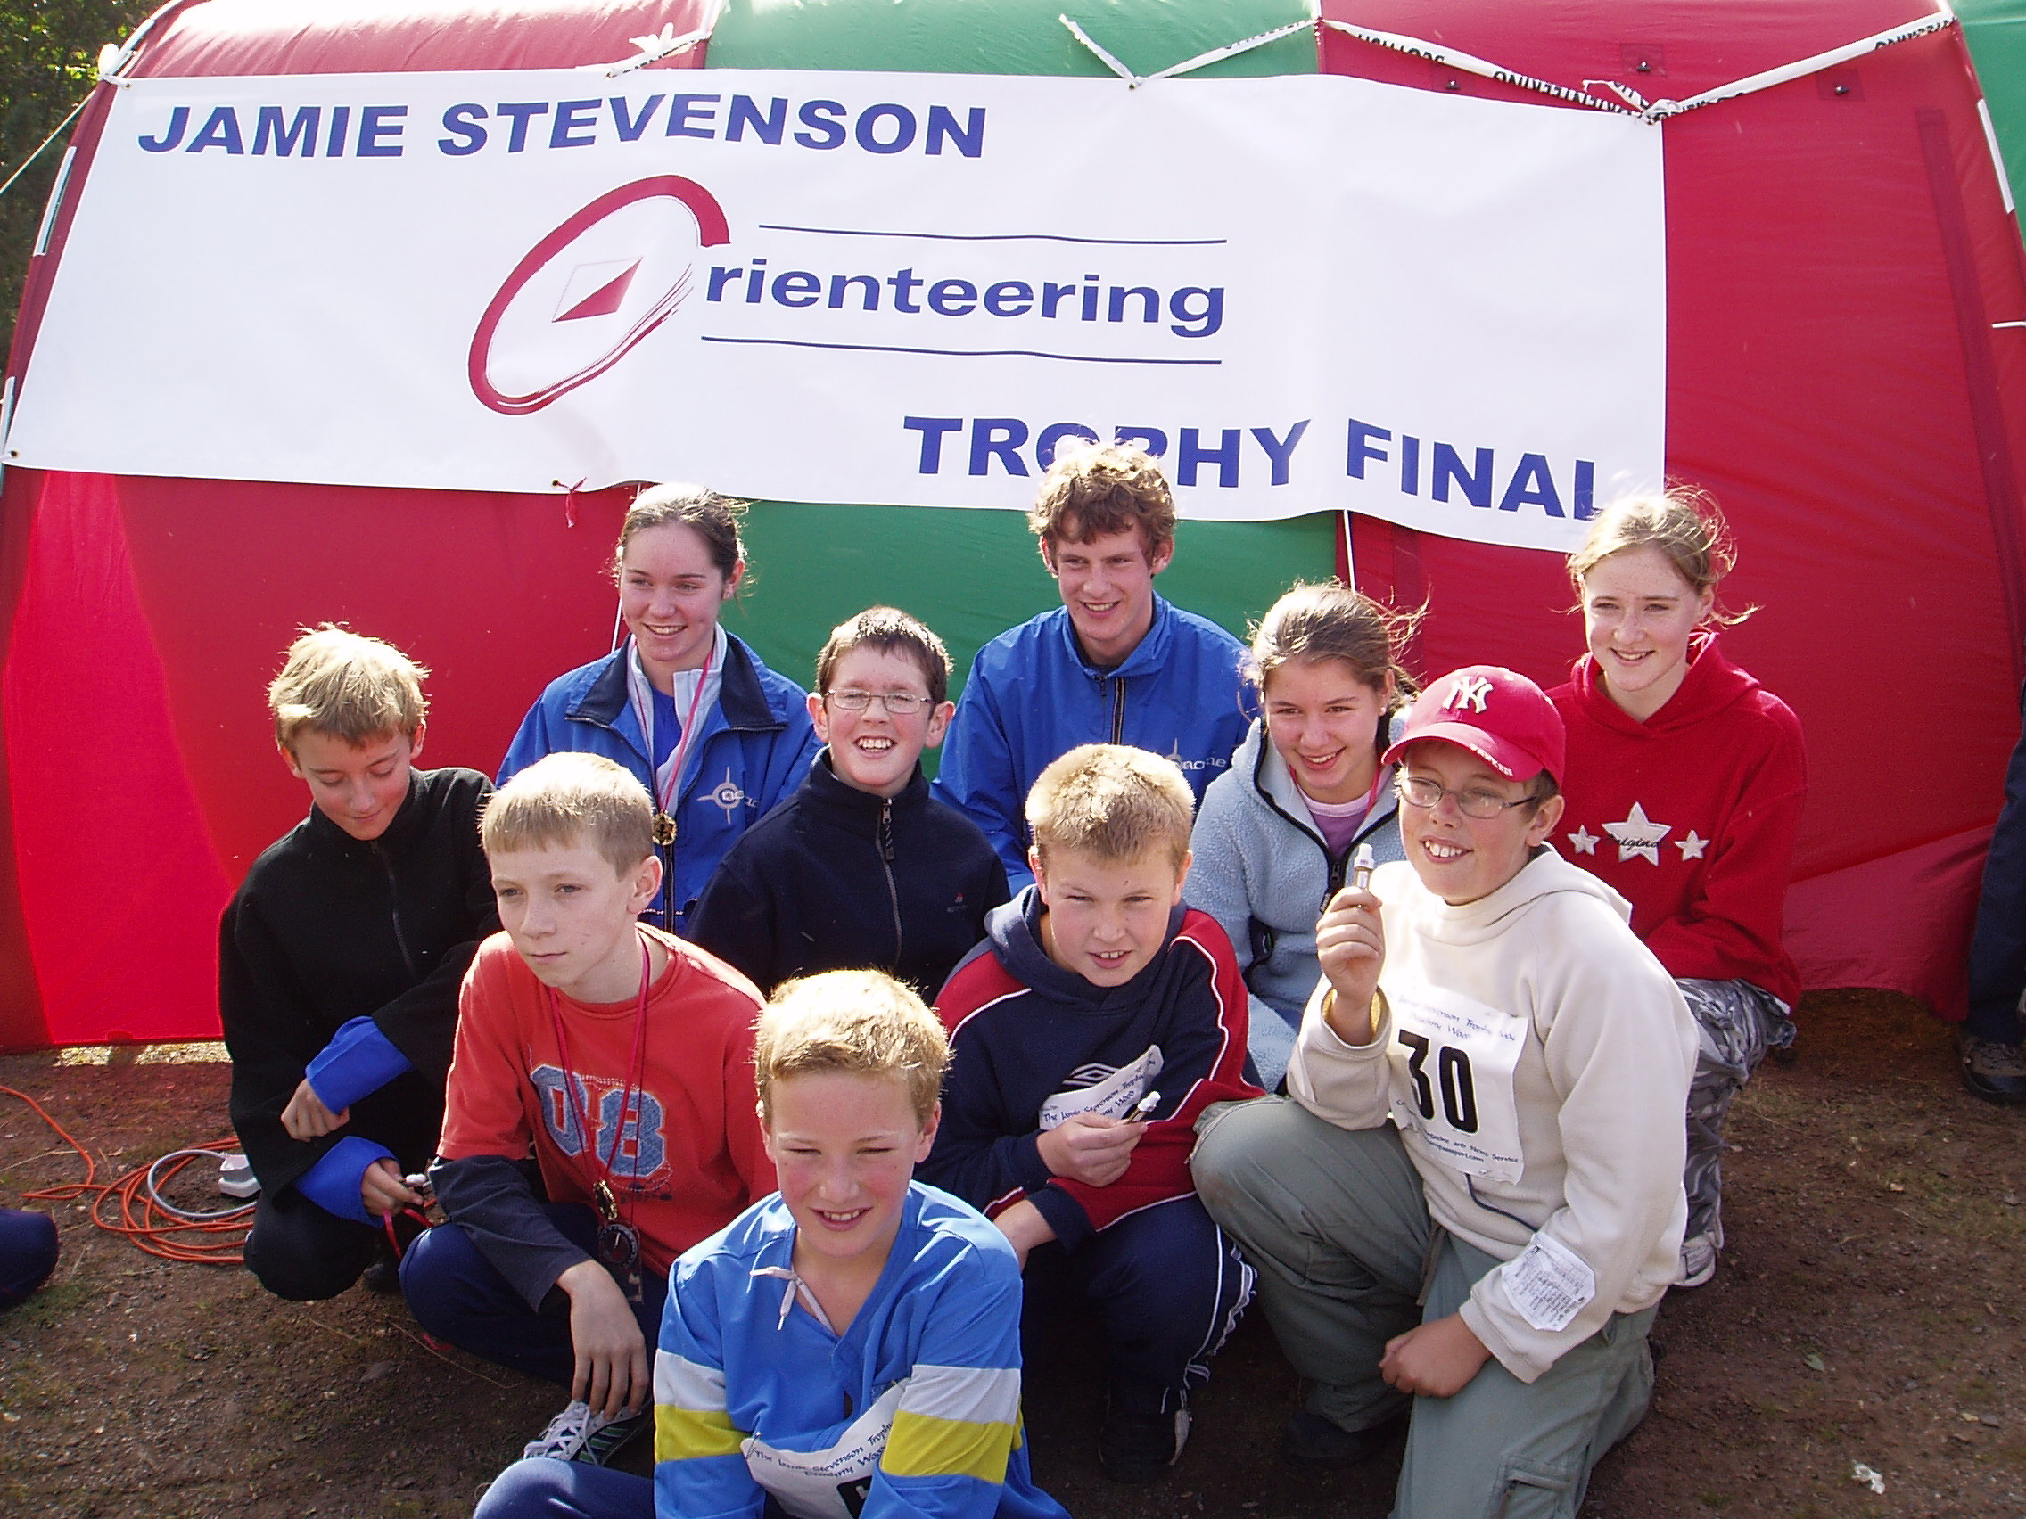
www.fvo.org.uk

